Assignment AO3 - Problem Definition

Homeless Shelter

**Task**: Seeking an affordable and efficient shelter that can withstand different weather conditions.

**Pains**:

1. Shelter is not typically portable and is difficult to move from location to location
2. Homeless people do not have enough income to afford permanent and effective shelter
3. Homeless people often have to settle for sleeping under bridges or in areas that are not very safe without any shelter to protect them
4. Homeless people are more prone to getting sick from exposure to the elements

**Gains**:

1. Homeless people gain more of a sense of privacy and personal space
2. Homeless people have the warmth they need to protect them from the cold
3. The ability to have a portable shelter and extra storage to protect their belongings from the general public

**Graphics**:

Assessing User Experience of Homeless People in Finding/Using Shelter

| -- | - | 0 | + | ++ |  |
| --- | --- | --- | --- | --- | --- |
| X |  |  |  |  | Privacy |
|  | X |  |  |  | Storage of personal belongings |
| X |  |  |  |  | Comfort |
|  | X |  |  |  | Access to food |
|  | X |  |  |  | Ease of transportation |
|  | X |  |  |  | Ability to access shelter |
| X |  |  |  |  | Protection from sickness |
|  | X |  |  |  | Sense of community |
| X |  |  |  |  | Safety |
|  | X |  |  |  | Access to medical resources |
|  |  |  |  | X | Using a portable shelter |

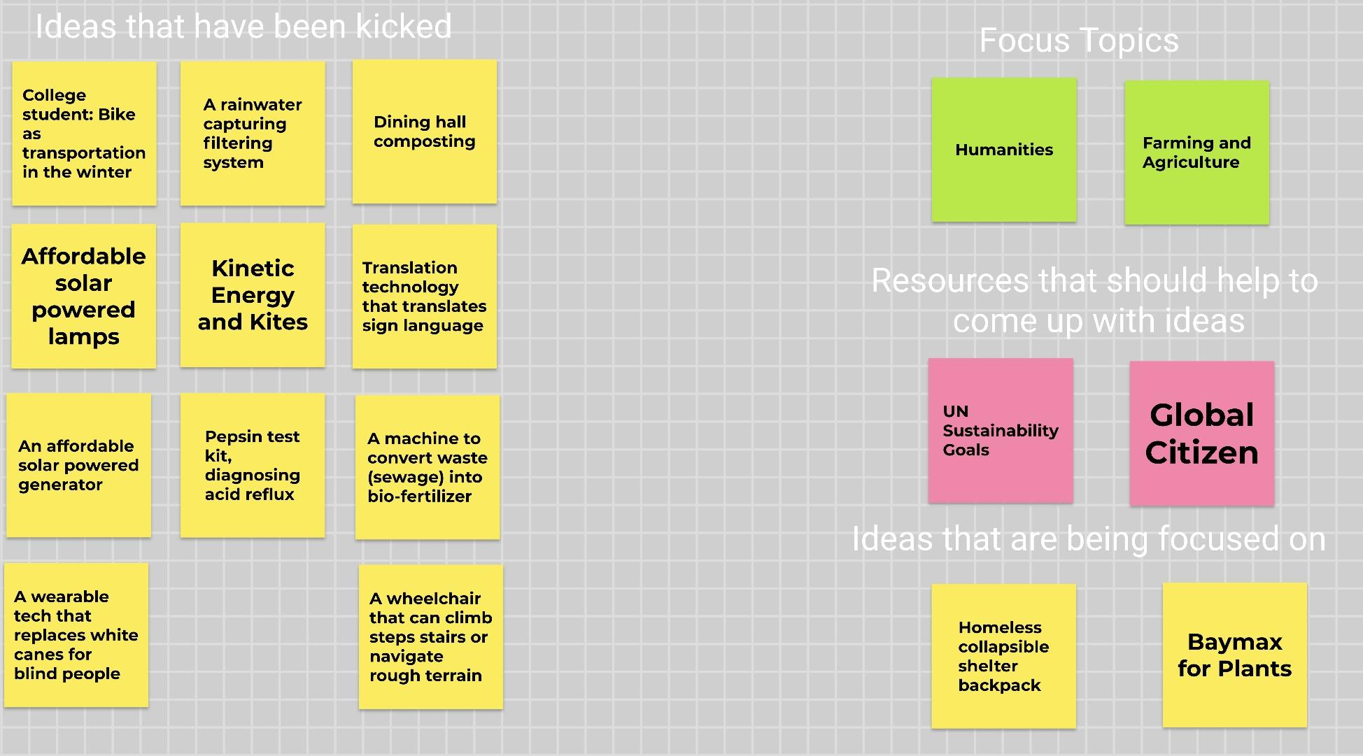

**Appendix**:

| **AO3 Assignment** | | | |
| --- | --- | --- | --- |
| **Project Manager for Assignment** | | | |
| Leah Norton | | | |
| **Deputy Manager for Assignment** | | | |
| Avi Popat | | | |
| **Drafted Assignment** | **Reviewed Assignment** | **Revised Assignment** | **Proofread Assignment** |
| Leah Norton | Ashwin Rajkumar | Avi Popat | Ella Wulforst |
| **Created Figures** | | **Created Tables** | |
| Ashwin Rajkumar | | Ella Wulforst | |
| **Other Contributions** | | | |
| N/A | | | |
| **Problems Overcomes** | | | |
| N/A | | | |